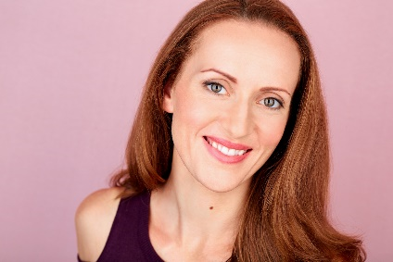REBEKAH PADRO AEA

BELTER/SOPRANO TO HIGH D

HAIR: Auburn EYES: Hazel

HEIGHT: 5'5"

EMAIL: rebekahpadro@gmail.com

PHONE: (360) 269-9179

***REGIONAL THEATRE*** *(REPRESENTATIVE CREDITS)*

A CHORUS LINE Cassie Bainbridge Perf. Arts - *Steven Fogell*

CHICAGO Roxie Hart Bainbridge Perf. Arts - *Steven Fogell*

THE PRODUCERS Ulla Bainbridge Perf. Arts - *Teresa Thuman*

OKLAHOMA! Laurey Drew Harvey Theatre - *Nancy Hillman*

GEORGE M! Josie Cohan Seattle Musical Theatre - *Greg Morales*

THE PIRATES OF PENZANCE Mabel Centralia Theatre – *Brian Tyrrell*

NUNSENSE II: THE SECOND COMING Sister Robert Anne Seattle Musical Theatre - *Bryce Britton*

KISS OF THE SPIDERWOMAN Featured Ensemble/Dance Captain Secondstory Rep - *Billie Wildrick*

DIRTY ROTTEN SCOUNDRELS Renee/Dance Captain Theatre NW Group - *Chris Nardine*

ANNIE GET YOUR GUN Mrs. Schuyler Adams/Ensemble Village Theatre - *Steve Tomkins*

GODSPELL ‘By My Side’/‘Light of the World’ Renton Civic Theatre - *Kent Phillips*

HELLO, DOLLY! Ensemble Village Theatre *- Steve Tomkins*

OKLAHOMA! Ellen/Ensemble Village Theatre *- Steve Tomkins*

STUNT GIRL Ensemble Village Theatre - *Steve Tomkins*

BEAUTY AND THE BEAST Ensemble Village Theatre - *Steve Tomkins*

EVITA Ensemble Swing (performed) Village Theatre *- Brian Yorkey*

AIDA Ensemble Swing (performed) Village Theatre - *Brian Yorkey*

RETURN TO PARADISE Galaxy Girl Teatro Zinzanni - *Norm Langill*

***PRINT***

BARTELL DRUGS Principal Lauren Shelzam - Z Photographie

MIDNIGHT BUFFET - BUSCH GARDENS Lady of the Gardens - Principal Oh, Hello

***COMMERCIAL***

TACO TIME Principal Leonard Creative

MIDNIGHT BUFFET - BUSCH GARDENS Lady of the Garden - Principal Oh, Hello

PEACEHEALTH Principal Handcrank Films

ISHARES Hand Model Superfad

VOLKSWAGON TIGUAN Body Double PrettyBird Productions

# *TRAINING*

# *ACTING*: Associate of Arts in Theatre/Acting (Meisner-based) – Centralia College (Brian Tyrrell)

# Acting for the Camera – Mighty Tripod Productions (Tony Doupe, David S. Hogan)

# Audition Freedom/Build Your Book Workshops– MaxTheatrics (VP Boyle)

***MUSIC*:**  Private Vocal Study– Darius Etemedieh, Ann Evans, Jadd Davis

Piano Performance/Music Theory - Clarita Burden

***DANCE*:** Intermediate/Advanced Ballet - SW Washington Dance Centre, Pacific Northwest Ballet, Steps on Broadway

AdvancedJazz – SW Washington Dance Centre, Steps on Broadway

Intermediate Tap – SW Washington Dance Centre, Steps on Broadway

Intermediate Modern – SW Washington Dance Center, Velocity Dance

# *SPECIAL SKILLS*

Dialects (American Southern, Various East Coast, British RP, Cockney); Excellent whistler; 1-handed cartwheels and round-offs; Very flexible; Can sight-read music; Intermediate-level pianist; Can carry 4 loaded dinner plates at the same time